BAY CITY HOUSING COMMISSION
315 14th Street ~ Bay City, Michigan 48708
(989) 892-9581 fax (989) 892-5818 tdd (800) 545-1833 ext 561

RFP Replace Check Valve on Fire Sprinkler Input Water line at Pine Towers

This project will include removal and replacement of the fire water line at Pine Towers, owned and operated by the Bay City Housing Commission.

Scope of work: 1st floor, fire sprinkler input water line replace 6” single check valve with double check valve as per state and municipal code.

Material. Series 757, 757N Double Check Valve Assembly from Watts or owner approved equivalent. This assembly includes two shut off valves however it is longer than the existing single check and shut off valve we need to replace, so modification of the existing 6” piping will be needed.

Pre-Bid site inspection available at your convenience. Contact Karl Opheim, Assistant Director at (989) 892-9581 x107 or email Karl@baycityhousing.com to schedule your visit. We recommend each interested vendor visit each site prior to submitting your quote.

Bid Submission, Due Date and Time. All bids shall be submitted on proposal forms, included in this solicitation, are due Thursday, June 15, 2023 at 12:00 Noon either by email to Karl@baycityhousing.com or mail or drop off at Administration Office, Bay City Housing Commission, 315 14th Street, Bay City, Michigan 48708. Bidders may also include their proposed scope description with pricing on company letterhead.

If you email your quote, we request an original signature copy must follow by three business days.

Non-Debarred / Non-Collusive form. Bidders will need to certify that neither they nor the firm,
partnership or association in which he/she has substantial interest is designated as an ineligible
contractor by the Comptroller General of the United States pursuant to Section 5.6(b) of
the Regulations of the Secretary of Labor, 29 CFR Part 5, or that any part of this contract has
been or will be subcontracted to any subcontractor if such subcontractor, firm, corporation,
partnership or association in which such subcontractor has a substantial interest is designated as
an ineligible contractor as noted by regulatory provisions.

Payroll Reports. Each contractor and/or subcontractor on site will be required to complete and submit payroll form WH-347 and Statement of Compliance, form WH-348, for each week during the course of work. Davis Bacon prevailing wages and benefits rates will not apply to this project.

Bid Evaluations and Contract. Bay City Housing Commission reserves the right to reject any or all proposals, to waive any informality in the quote request process, or to terminate this quote process at any time, if deemed by BCHC’s to be in its best interests. Under the competitive proposal process negotiations of price and revision of scope may be necessary if available funding is less than the lowest qualified bid received. We are requesting a single bid for this project.
HUD General Conditions Instructions F0RM 5370 EZ will apply to all contracts under $100,000 will be followed with this project. A copy is available upon request. The web address for a copy is: http://portal.hud.gov/hudportal/HUD?src=/program_offices/administration/hudclips/forms/hud5a
or you can contact Karl Opheim, Assistant Director at 989-892-9581 ext. 107.

Bay City Housing Commission Pine Towers Check Valve Replacement
Page 2

All work on this project shall be in accordance with all applicable federal, state and local codes and regulations having jurisdiction over this project. Bids shall include all state and local permits, fees and taxes. A municipal plumbing permit is required.

If discrepancies are found between the information provided and the actual field conditions, the Contractor shall notify the Owner within one (1) business day of the discrepancy discovery. Failure to do so indicates acceptance by the Contractor.

Site hours and scheduling. All work shall be performed during regular business hours Monday through Friday between 7:30 a.m. to 4:00 p.m., excluding official Housing Commission holidays. Contractor shall protect all occupied areas from damage. Be certain the building and property shall be clean and free of debris at the end of the workday. Contractor shall replace, at their expense, any property or material damaged during removal or storage of equipment.

Warranty. All materials, equipment and workmanship as described in this specification or amended by any change order shall be guaranteed for a period of one (1) year from the date of completion for all materials and labor. Bidder shall specify if the materials have any additional warranty time. Notification to correct, repair or replace any defective materials or workmanship shall be from the Owner, in writing to the Contractor.

Liability and Worker’s Compensation Insurance. No work under any contract or agreement may begin without proof of liability and workman’s compensation insurance in force and Certificate(s) of Insurance have been received by BCHC as required by policy including the Certificate of Insurance on file with the Executive Director. All policies shall name the Bay City Housing Commission as an additional named insured on a primary and non-contributory basis. A completed IRS W9 is required for the successful bidder. We use a bill payment service for processing payments so BCHC recommend each new vendor to sign-up for the electronic payment deposit.

Workers’ Compensation and Occupational Disease Insurance. In accordance with federal and Michigan Workers’ Compensation laws. Such coverage must specifically identify coverage as required by state law. The employer’s liability limit must be a minimum of $100,000 per accident and $100,000 per disease, per employee with policy limit of $500,000.

Commercial General Liability. A combined single limit for bodily injury and property damage of not less than $1,500,000 per occurrence to protect the Contractor and each subcontractor against claims for bodily injury or death and damage to the property of others. This shall cover the use of all equipment, hoists, and vehicles on site(s) not covered by Automobile Liability. If the Contractor has a “claims-made” policy, then the following additional requirements apply: the policy must provide a “retroactive date” which must be on or before the execution date of the Contract; and the extended reporting period may not be less than five years following the completion date of the Contract.

Automobile Liability is required on owned and non-owned motor vehicles used on the site(s) or in connection therewith for a combined single limit for bodily injury and property damage of not less than $500,000 per occurrence.

Voluntary alternate bid. Bidders may submit voluntary alternate proposals for different or enhanced equipment or materials for our consideration. Brochures and any other information must accompany any alternate submissions.

Bay City Housing Commission Pine Towers Check Valve Replacement
Page 3

Single check valve to be replaced with Double check valve
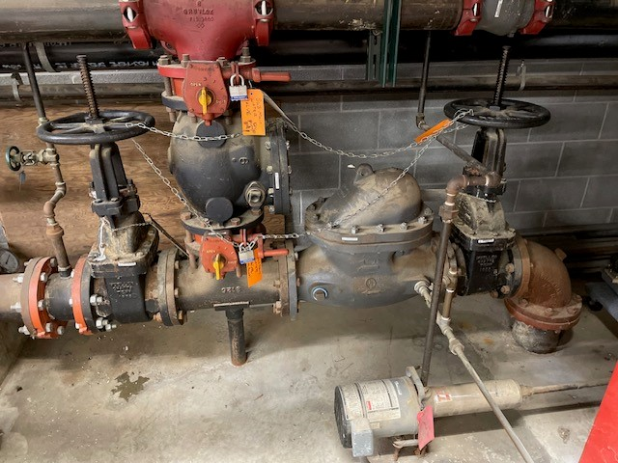

31 3/16” flange to flange

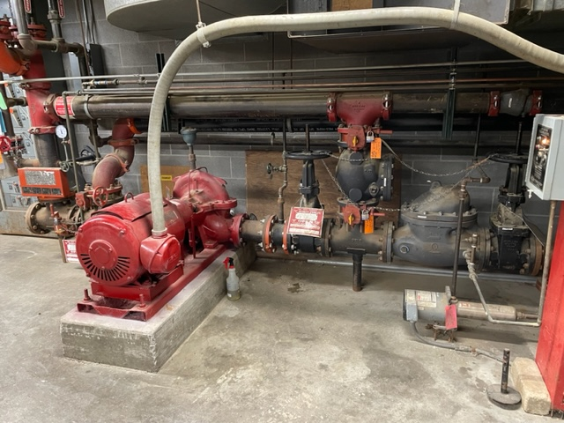

Exterior fire dept connection line top pipe

Bay City Housing Commission Pine Towers Check Valve Replacement
Page 4

1984 Drawing from Fire Pump Installation. This is not an “as-built” drawing, bidders will need to measure themselves for accuracy.
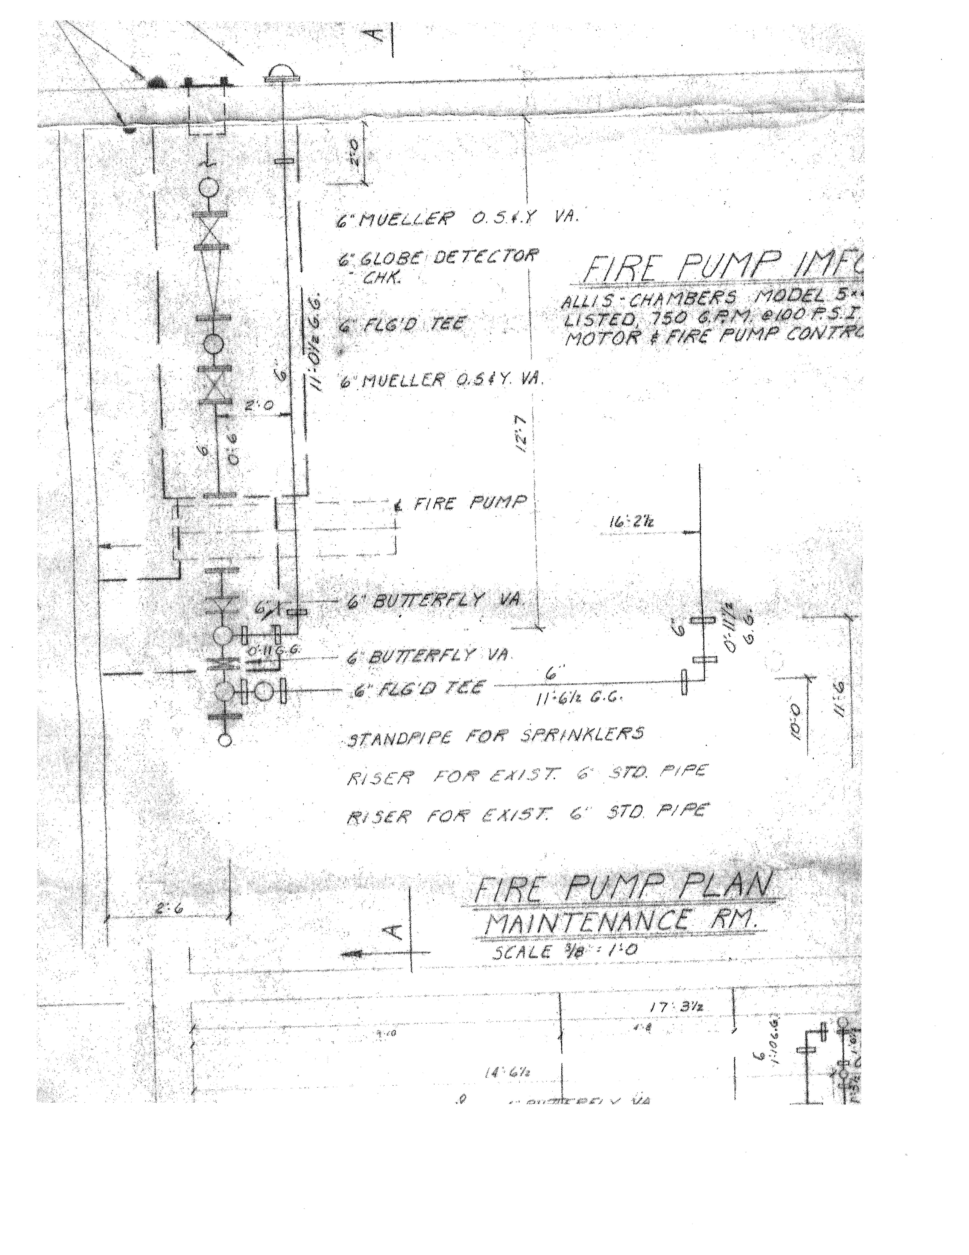

PASTE or TYPE BIDDER'S LETTERHEAD HERE and SUBMIT WITH PROPOSAL)

NON-COLLUSIVE AFFIDAVIT

State of (___________) ss.

County of (_________)

____________________________________________, being first duly sworn, deposes and says:

That he/she is ____________________________________ (a partner or officer of the firm of, etc.) the party making the foregoing proposal or bid, that such-proposal or bid is genuine and not collusive or sham; that said bidder has not colluded, conspired, connived or agreed, directly or indirectly, with any bidder or person, to put in a sham bid or to refrain from bidding, and has not in any manner, directly or indirectly sought by agreement or collusion, or communication or conference, with any person, to fix the bid price or of any other bidder, or to fix any overhead, profit or cost element of said bid price, or of that of any other bidder, or to secure any advantage against the Bay City Housing Commission or any person interested in the proposed contract; and that all statements in said proposal or bid are true.

NON-DEBARRED CERTIFICATION

This is to certify that the below signed bidder is not nor have been debarred, suspended or otherwise prohibited from contacting or entering into construction or modernization agreement with any federal, state or local agency including the U.S. Department of Housing and Urban Development.

Date: ___________________ Signature: _____________________________________
Bidder, if the bidder is an individual
Partner, if the bidder is a partnership
Officer, if the bidder is a corporation

Subscribed and sworn to ______________________ before me

This _________day of _______________________ 20 ______.

My commission expires ____________________ 20 ______

PROPOSAL FORM

⇨ PLEASE PASTE YOUR COMPANY’S LETTERHEAD AT THE TOP OF THIS PAGE

Bid For: Pine Towers Check Valve Replacement

To: Bay City Housing Commission (owner)
315 14th Street
Bay City, MI 48708
Gentlemen:

The Undersigned, having familiarized myself with the local conditions affecting the cost of this work, and the Contract Documents (Advertisement and Instructions to Bidders, Non-Collusive Affidavit, HUD 5370 EZ General Conditions, Description of Work) and any Addenda issued, hereby proposes to perform everything required to be performed and to provide and furnish all the labor, materials, tools, expendable equipment, utility and transportation services, etc., necessary to perform and complete in a workmanlike manner all of the Building Trades Work required under the Base Bid for the aforementioned project, all in accordance with the Contract Documents prepared by Bay City Housing Commission in connection with, and any addenda issued thereto, for the sum of:

__________________________________________________ Dollars ( $ ________________ )

VOLUNTARY ALTERNATES

Voluntary alternates for substituting material or equipment. Attach detailed specification.

Describe __________________ PRICE $_____________

- In submitting this bid, it is understood that the right is reserved by the Bay City HousingCommission to reject any or all bids. If written notice of the acceptance of this bid is mailed, telegraphed, or delivered to the undersigned within thirty (30) days after the opening thereof, or at any time thereafter before this bid is withdrawn, the undersigned agrees to execute and deliver a contract on the prescribed form.

2. Attached hereto is an affidavit in proof that the Undersigned has not entered into any collusion with any person in respect to this proposal or any other proposal or the submitted proposal for the contract for which this proposal is submitted.

3. The bidder represents that he ( ) has, ( ) has not, participated in a previous contract subject to the Equal Opportunity clauses prescribed by Executive Orders 10925, 11114, or 11246, or the Secretary of Labor, and that he ( ) has, ( ) has not, filed all required compliance reports; and that representations indicating submission of required compliance reports, signed by proposed subcontractors, will be obtained prior to subcontract awards. (The above representation need not be submitted in connection with contracts or subcontracts which are exempt from the Clause).

Bay City Housing Commission Plumbing Repairs
PROPOSAL FORM, page 2

4. Completing Date: The undersigned agrees if awarded the contract, to complete the work in full on or before the time proposed below.

SCOPE Estimated completion time (calendar days)

Base Bid ________

NOTE: The penalty for making false statements in offers is prescribed in 18 U.S.C. 1001.

The information contained in this proposal is to be relied upon by the Bay City Housing Commission, and such information is warranted by the bidder to be true. The bidder agrees to furnish such additional information, prior to acceptance of any proposal relating to the qualifications of the bidder, as may be required. Attach additional sheets if necessary.

Signed: ____________________________________ Date: ___________________, 2023

Print/Type Name: ________________________________ Title: _________________________
Company Name: ___________________________________________________
Address: _________________________________________ City/Zip: ____________________
Telephone: _____________________ Email: _______________________________________

Bids are due Thursday, June 15, 2023 at 12:00 Noon at Bay City Housing Commission, 315 Fourteenth Street, Bay City, Michigan 48708 via mail or other direct delivery, email to (Karl@baycityhousing.com). All email submissions must be followed by a signed hardcopy within three business days.

